1. **whoami** 🡪 To get the username

1. **pwd** 🡪 To see the directory you are currently working with Text

   Description automatically generated with low confidence
2. **ls** 🡪 to list the directories 
3. **ls -la** 🡪 List the directories including hidden and with other details 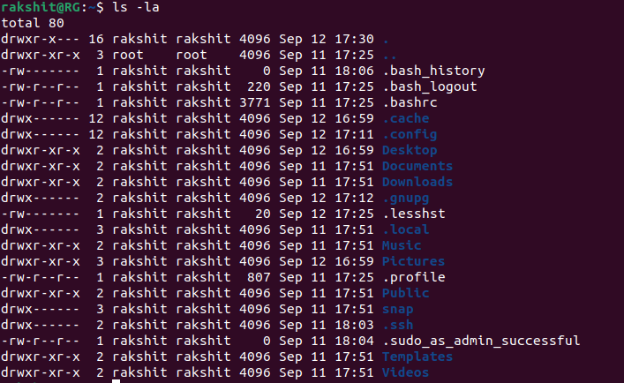
4. **cd <directory name>** 🡪 To enter the directory



1. **cd ..** 🡪 To go to the previous directory Graphical user interface, text

   Description automatically generated with medium confidence
2. **cd** 🡪 To go to home directory



1. **cd <path>** : open a particular directory using path Text

   Description automatically generated
2. **touch <file name>** 🡪 To create a file 
3. **touch <file name>{from..to}** 🡪 To create multiple files ending with from to to.



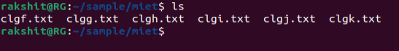

1. **vi / nano** 🡪 Open the writing mode

**vi**

**nano**

1. **vi / nano <file name>** 🡪 create a file and open in writing mode

**vi** 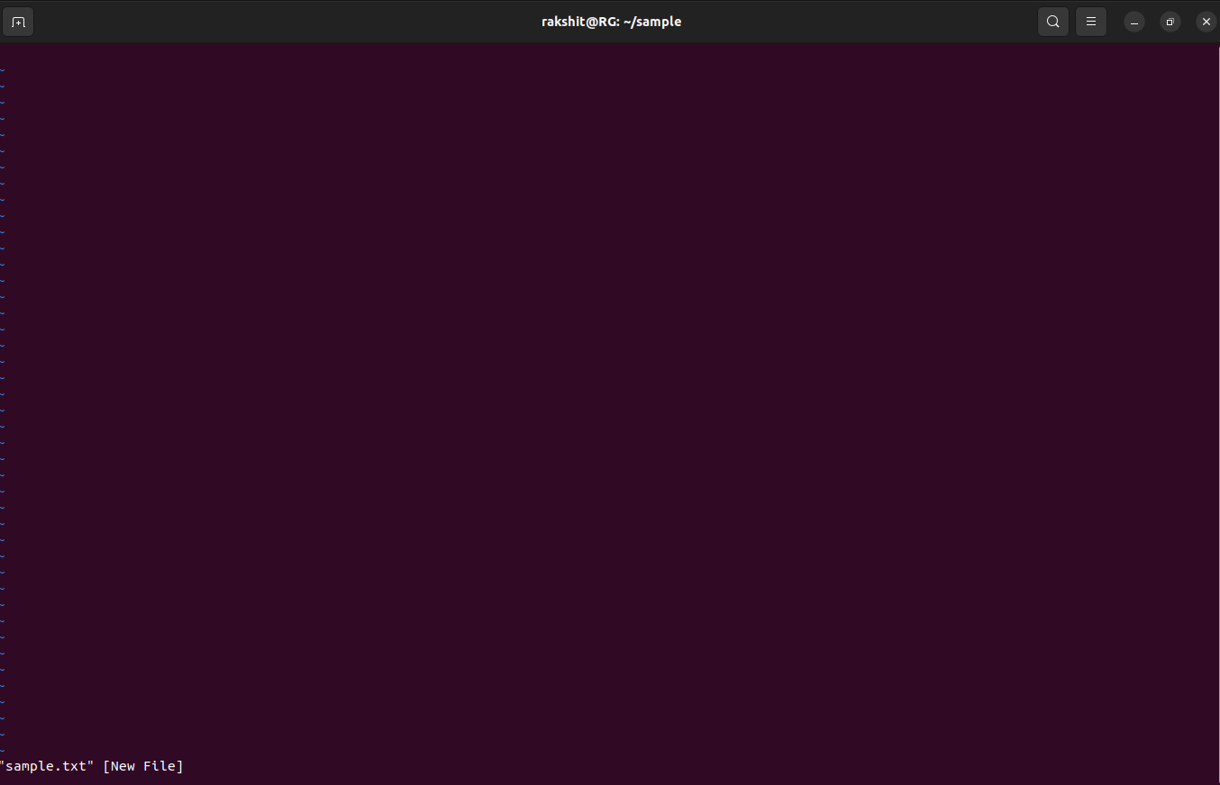

**

1. **echo<string>** 🡪 To print the string 
2. **hostname** 🡪 To get the hostname

1. **cat <file name>** 🡪 To read the file

1. **mkdir<directory name>** 🡪 create a directory 
2. **mkdir -help** 🡪 help in mkdir 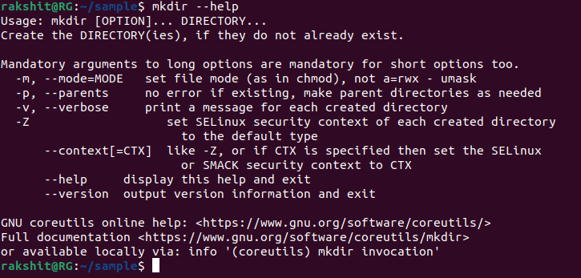
3. **mkdir -v <directory name>** 🡪 create a directory and give output for status Text

   Description automatically generated
4. **mkdir -p <directory name/next directory>** 🡪 Create a directory path 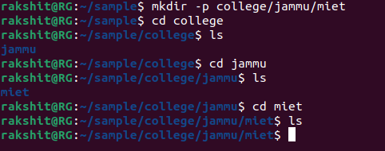
5. **mv <old file name> <new file name>** 🡪 to renaming a file Text

   Description automatically generated
6. **mv <file name> <path where to move>** 🡪to move a file 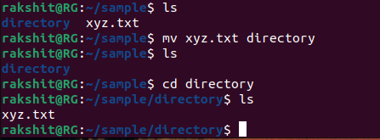

1. **mv -i <file name> <path where to move>** 🡪to move a file and take permission to overwrite if file exists Text

   Description automatically generated Text

   Description automatically generated
2. **mv -n <file name> <path where to move>** 🡪to move a file but reject for overwriting if file already exists  Text

   Description automatically generated
3. **mv -b <file name> <path where to move>** 🡪to move a file and getting the backup of the file before overwritingText

   Description automatically generated
4. **cp<file1> <file2>** 🡪 to copy file1 in file2 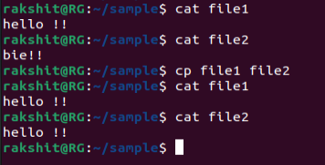
5. **cp -i <file name> < file2>** 🡪to copy a file and take permission to overwrite if file exists



1. **cp -n <file1> < file2 >** 🡪to copy a file but reject for overwriting if file already exists

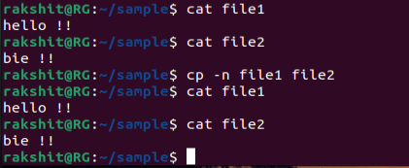

1. **cp -b <file1> < file2 > 🡪** to copy a file and getting the backup of the file before overwriting 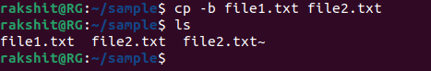
2. **cp -v <file1> < file2 > 🡪** to copy a file and getting the path of new file 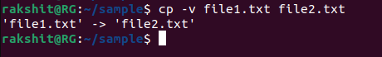
3. **cp -r <file1> < file2 > 🡪** to copy a directory 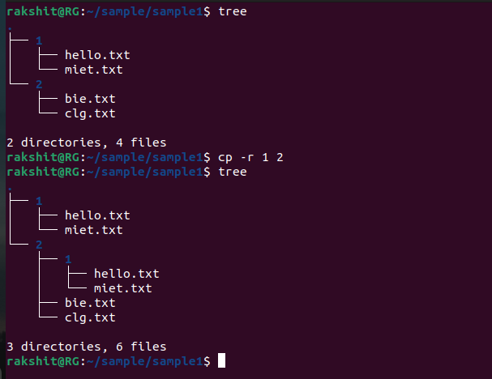
4. **cat <file1> > <file2>** 🡪 copy file 1 content to file 2 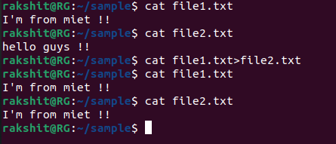
5. **cat <file1> >> <file2>** 🡪 Append file 1 content to file 2 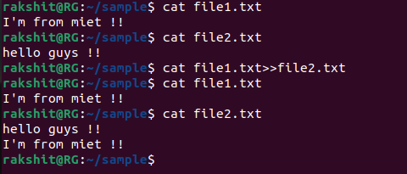
6. **cat <file1> <file2> > <file3>** 🡪 copy file 1 and file 2 content to file 3 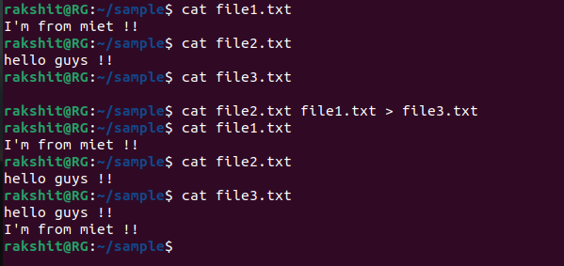
7. **cat <file1> <file2> >> <file3>** 🡪 append file 1 and file 2 content to file 3 Text

   Description automatically generated
8. cat – n <file> 🡪 Show number to lines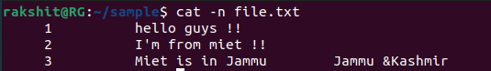
9. cat – e <file> 🡪 print dollar symbol ‘$’ at the end of every line Text

   Description automatically generated
10. cat – t <file> 🡪 Print ‘^I’ in place of every tab 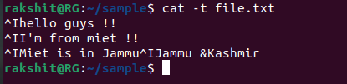
11. **rm <file name>** 🡪 to delete a file Text

    Description automatically generated
12. **rmdir <directory name>** 🡪delete empty directory

1. **rmdir -p <directory name/next directory>** 🡪 Delete a directory path Text

   Description automatically generated
2. rm -r <directory name> 🡪 to delete a directory 